CURRICULUM VITAE
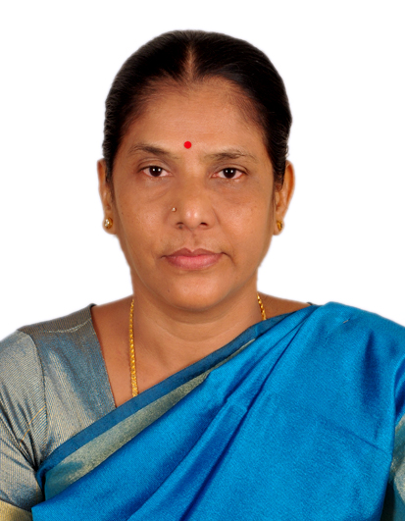
Mrs. Saradha. S,
No 9, VGN Milano Square,
Kamarajar Street, East Tambaram,Chennai-59.
Mobile No: 94445 70958
E-mail ID: sarakottaiyan@gmail.com
DOB: 08.04.63
_____________________________________________________________________

VISION

“TO BE THE BEST VISIONARY, VIBRANT EDUCATIONIST IN THE FIELD OF EDUCATION BY EXECUTING THE UNDERTAKEN TASK WITH LOYALTY, COMMITMENT & PERSEVERANCE.”

Professional Profile

Qualification : M. A, B.Ed., M.Phil.

Specialization : English

Experience : 30yrs. (16 yrs Principal, 1yr - CEO - Pon
Vidhyashram Group of CBSE Schools,
13 yrs. PGT, English at SBOA)

Current Designation : Serving as a Principal for Shikshaa Public School, Chromepet from 2025 April to till date.

Current CTC : 1,00,000/- Per Month

Previous Experience : 2018 April - 2024 March 31,
Principal of SMK Vidhyashram & Junior
College, Kodungaiyur.

2015 -2018 March, Principal of Terapanth
Jain Vidhyalaya MHSS, Sowcarpet

: 2013 - 2015
Educational Advisor &
Principal for Shree Sankalpa
School, CBSE,Guduvancherry

: 2011 - 2013
Principal for
Satheesh Balaji MHSS.

: 2009-2010
Headmistress in The Govt.Aided School named A.G Jain HSS, Sowcarpet.

: Principal of SJT Surana
Jain Vidhyalaya, Sowcarpet from 2008 to
2009.

: 2006-08,
Headmistress for the Senior Secondary in The Velammal International School, Panchetti.

: Worked in London from 2005-06 with HSMP Visa, UK

: 1992-2005 (13 yrs.), PGT Senior English Teacher in SBOA MHSS Anna Nagar West Extn.

ACCOMPLISHMENTS: Implemented AI, Coding & Robotics
at the Primary classes itself.

Made the pupils complete the certificate course in Computer Science
in Grade eight by registering the school in the renowned university.

Educational Consultant, Academic
Adviser, English Language Skills’
Trainer, Event Manager & Educational Website Designer.

Served as a Consultant to set up New
Global School at Jamin Korattur with
IGCSE, IB & CBSE Curriculum,
Sree Sankalpa School, CBSE at
Guduvancherry

Designed the website of the schools
Where ever I served as a School Head

- Trained teaching staff and pupils to enhance their LSRW
- Served as the Head & the Trainer for SMK VIDHYASHRAM Nursery & Primary teacher Training Institute
- Conducted Orientation Programmes, CCE (CBSE&MATRIC) trained to master Soft skills, rendered effective periodical workshops and seminars to the teaching fraternity to enrich their professional skills
- Trained & motivated the staff and the students to take part and bag the accolades in all sorts of contests, sports & games at various levels
- Set up Multimedia English Language Lab
- Efficient Administrator, Committed Academician, Effective
Subject Expert, Conscious Counseller
& Dynamic Disciplinarian.
- Author & Editor of School Academic Year Planner, Dossier, Prospectus, Magazine, Souvenir, Advertisements & School Diary

- Choreographed for all the Cultural
Programmes, Managed the Thematic Relevant
Events Aesthetically & Effectively

NOTEWORTHY DEEDS :

- Toured to Singapore & Malaysia and visited the Educational Institutions over there.
- Introduced various CCA &ECA
- Trained the staff to teach through the Digital Training System & PPT
- Various staff committees were formulated
- Encouraged the staff and the students to enhance their communication skill
- Students & staff were motivated to showcase their potential
- In order to gain entry into the globally renowned institutions, Trinity College of London ASL Examination & Competitive Exams were introduced
- International Exchange Programmes (USA) for students were being conducted.

SPECIAL INTERESTS:

To master the latest technology, work for the Woman’s Empowerment, learn foreign languages & experimenting innovative ideas.

HOBBIES:

Viewing English Reality Shows, Listening to Music & Zen Stories, Reading Informative Books, Articles and Indian Epics.

REFERENCES:

- Sri R.Vivekanantan,
Former President &Chairman of Sree Muthukumaraswamy Educational
Society.

Mobile No: 9382150802

2. Mr.Karthikeyan
Former Correspondent of Kalaimagal Matriculation & HSS

Mobile: 9841111026

Date: 22.09.25 Signature: S Saradha

