RESUME

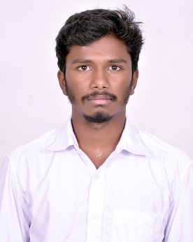
SATHISHKUMAR. M

14
, Kkpudhur,

JJ Nagar ,

Udumalpet (TK)
–

642128

PHONE : 8870715427

EMAIL :
Sathishmaster2207@gmail.com

OBJECTIVE

To be associated with an organization where I can update my knowledge and skills in the field of teaching and of the beneficiary of the same.

ACADEMIC RECORDS

Course | Institution | Board / University | Year of Completion | Marks %
M.A English Literature | Vidyasagar college of arts and science | Bharathiyar university | pursuing | 68.5
B.ED | Jsr college of education,Madathukulam. | TNTEU | 2023 | 78.76
B.A  Englishliterature | Government Arts and Science College, Udumalpet. | Bharathiyar University | 2020 | 50
HSC | Government Higher Secondary school, Udumalpet. | State Board | 2017 | 64.34
SSLC | Government Higher Secondary School, Udumalpet. | State Board | 2015 | 84.6

Additional Qualifications

- Typing skills English and Tamil

- CTET Cleard (92 marks)

PERSONAL DETAILS

Name : SATHISHKUMAR M
Gender : Male
Date of Birth : 22-07-2000
Marital status : Unmarried
Nationality : Indian
Hobby : Reading books
Languages Known : Tamil and English

DECLARATION

I hereby declare that the given information’s are true in my Knowledge and belief.

Date : Place :

(Sathishkumar.M)

